Extra Details in activities

**Step 1:**

**Pathway: Administration > System Settings > File Upload**

{Note: this is where you can upload a wide range of pictures and logos that can be used on your site. I would encourage you to also click on **General** just below **File Upload** where you could update your receipt logo; on-line Public Access Photo; header logo}

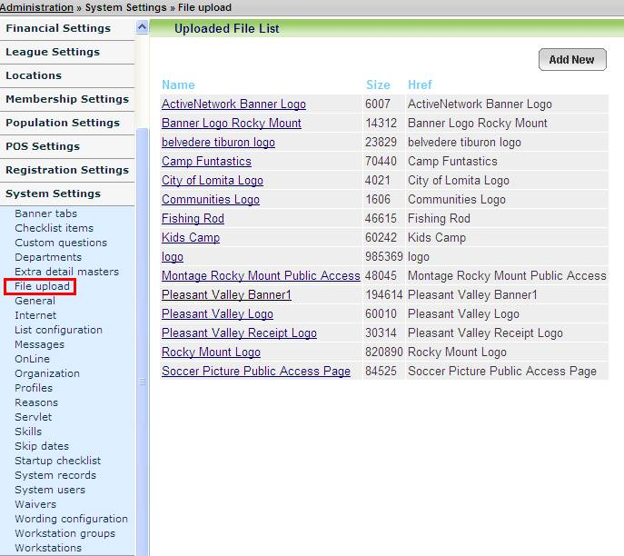

**Step 2:** Add Table

Note: need to add a table in Extra Detail Masters

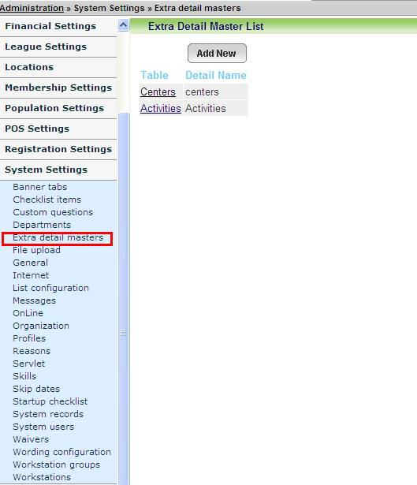

**Step 3:**

To add extra details to a specific Activity go to:

Pathway: Administration > Registration Settings > Activities > “____________” {choose a current class you know that you have in the system to get to the **Activity Functions Page** – under Name and Details see Change Extra Details Option}

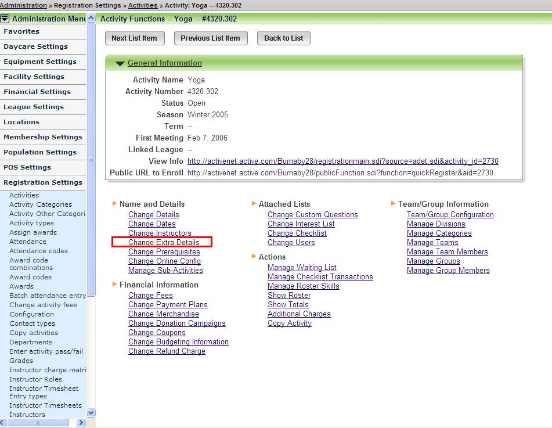

**Step 4:**

**Pathway: Administration > Registration Settings > Activities > “____________” {chose your activity} > Change Extra Details**

Note:

You have the option for Thumbnail Source to either select **URL** or **Upload** {which will give you the ability to select the source}

For Upload Attached File you have the option to click on the down arrow and choose a file that you have already uploaded in **File Upload** or **Upload** a new file

